Day 1 Lesson Plan – Intro to Biography: Helen Keller
Lower School Librarian

Grade Level: 2nd
Estimated Time: 40 minutes
AASL Standard: Inquire, think critically, and gain knowledge.
AASL Skills Indicators:
1.1.2: Use prior and background knowledge as a context for new learning.
1.1.3: Develop and refine a range of questions to frame the search for new understanding.
1.1.6: Read, view, and listen for information presented in any format (e.g., textual, visual, media, digital) in order to make inferences and gather meaning.
AASL Standard: Draw conclusions, apply new knowledge to new situations, and create new knowledge.
AASL Skills Indicator:
2.4.3: Recognize new knowledge and understanding.
AASL Standard: Pursue personal and aesthetic growth.
AASL Skills Indicator:
4.1.1: Read, view and listen for pleasure and personal growth.

Content Standards:
- Ask and answer such questions as who, what, where, when, why, and how to demonstrate understanding of key details in a text.
- Describe how characters in a story respond to major events and challenges.
- Determine a theme of a story, drama, or poem from details in the text, including how characters in a story or drama respond to challenges or how the speaker in a poem reflects upon a topic; summarize the text.
- Determine the meaning of words and phrases in a text relevant to grade 2 topics or subject areas.
- Identify the main purpose of a text, including what the author wants to answer, explain or describe.
- Describe how reasons support specific points the author makes in a text.

Provisions for Differentiation and Learning Styles:
- Verbal/Linguistic: Listen to the book/discuss ion after game and during reading of book
- Visual/Spatial: “Who am I?” game
- Body/Kinesthetic: Using fingertips to read Braille alphabet and “read” Braille picture book; creating names in Braille activity
- Interpersonal: “Who am I?” game

Instructional Plan
Engagement/Motivation (interest hook)
- Tell students they will begin the class by playing a game called “Who am I?” This game is similar to the one called “Hedbanz,” but the questions do not have to require yes/no answers. Each student will get a picture taped on her back. The picture is of a famous celebrity, sports star, world figure or cartoon character that most students should know. Keeping the pictures hidden, tape one picture on each child's back. Make sure that child doesn't know who is in the picture.
- Have each child ask another child questions to help her figure out who is on the picture. The questions can require more than just yes or no answers. Two children can take turns asking their own questions, or move on and ask questions of another child.
- The children will have to move around a lot and turn their backs to show the picture before asking a question. If a student is having trouble, give her some hints as to what might make a good question.
- When a child figures out the picture, tape it to her front and ask her to help others.
- Play the game for about 5 minutes, or until every child has figured out who is on her picture.
- Think-pair-share: Ask students to recall and share their experience with each other. How much difficulty did they have? What were some of the questions they came up with to help them with their guesses? What kind of information do you need in order to learn about a person?
Direct Instruction
- Explain to the students that one way to learn about a person, to have questions answered like the ones they used in the game, is through a biography. Write the word on the white board. Ask: “Does anyone know what a biography is?” On the board, write the definition: “a written story of someone’s life.” List and discuss some of the characteristics of a biography:
  - tells about a real person, either living or dead
  - generally written about someone whose life was unusually interesting
  - includes facts related to the person
    - dates
    - people and places
    - events
  - provides stories or details about the person in action
  - explains achievements and obstacles that person overcame
- Show students a copy of Helen Keller: Crusader for the Blind and Deaf by Stewart and Polly Anne Graff. Explain that the reason you are introducing the topic of biographies today is that they will be reading and studying this book in their language art classes. Tell students that today you will be sharing a short biography of a person related to Helen Keller’s life.
- Introduce the book A Picture Book about Louis Braille by David A. Adler. Ask students if they know what Braille is and what it is used for. Explain that Braille is a form of written language for the blind which uses raised dots that are felt with the fingertips. Pass around a few cardboard markers with Braille (obtained from the American Federation for the Blind). Ask students to close their eyes and feel the dots. Ask where students may have seen Braille before (they should mention the signs in halls and outside doors of the classrooms).
- Read the book. Ask the following questions during the reading:
  - What would it feel like to suddenly become blind when you were used to having your vision?
  - What challenges do you think Louis had to face once he became blind?
  - Why did Louis’ family send him to the National Institute for Blind Children?
  - How do you think a blind person like Louis could become a talented musician playing the piano, organ, violin and cello?
  - How do you think Louis felt when his coded system was rejected by the school?

Modeling/Guided Practice
- Distribute the handout which contains the Braille alphabet. Remind the students that Braille’s system is based on six dots, like dominoes. Say, “We are now going to do an activity that involves writing our first names in Braille.”
- Project the same handout via Elmo document camera and circle the letters in your own first name. Say, “We are going to use a non-traditional form of writing Braille using candy dots!” Show students the button candy on paper and how to form the Braille letters by removing the appropriate dots. Hold up the paper to show students the first name written in Braille.
Independent Practice
- Instruct students to circle the letters of their first name in the Braille alphabet.
- Distribute button candy paper and ask students to close their eyes and feel the texture of the dots. Explain that these dots are much larger than those traditionally used in Braille.
- Using the alphabet on the handout as a guide, students create their names in Braille.
Enrichment (to be passed around while students complete the activity) – Show students the Braille picture book Redbird by Patrick Fort and explain how it includes real words, Braille words and raised pictures with textures for children to feel. Show them the airplane, clouds and raindrops and encourage them to close their eyes as they feel the textures of these things.
Sharing and Reflecting/Student Self-Questioning/Formative Assessment – Students will fill out Exit Pass (see below) at the end of class.
Product – Student names in Braille – can be consumed!
Photos from Lesson:
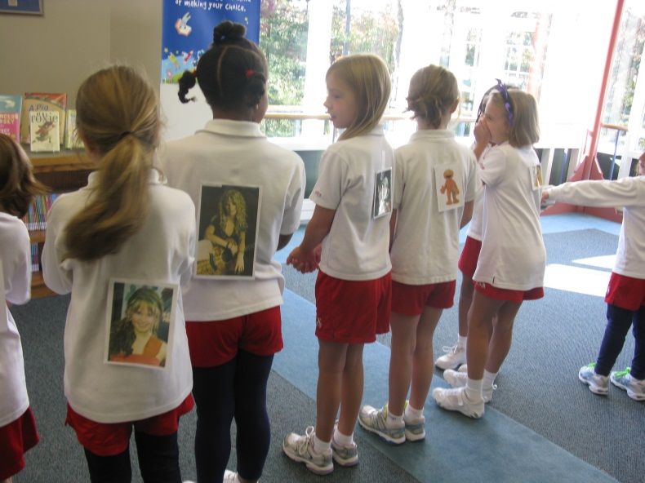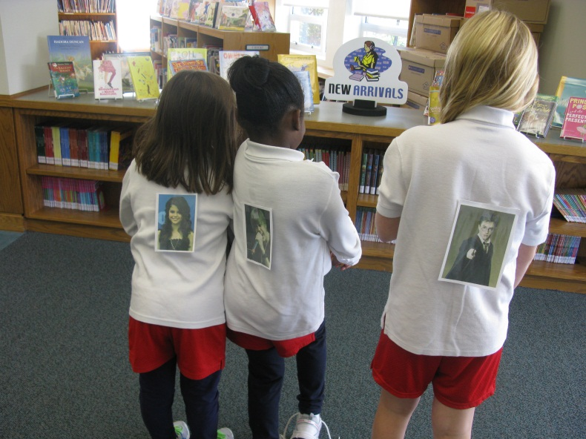
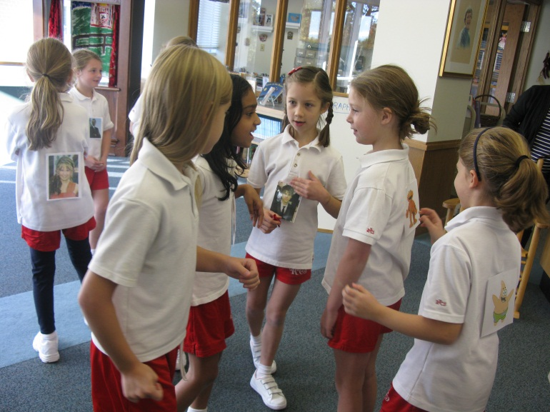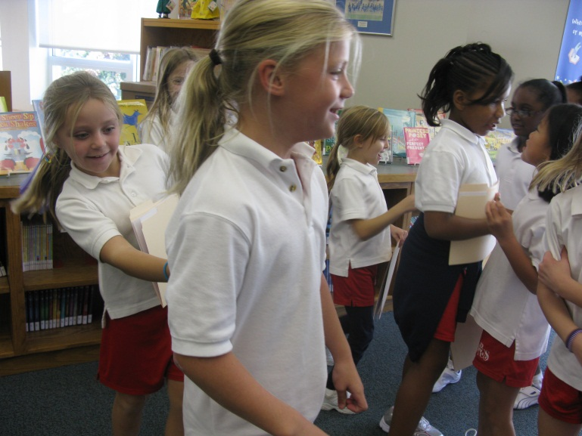
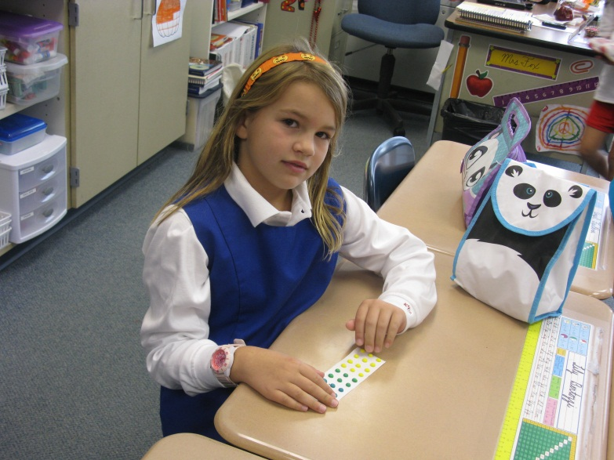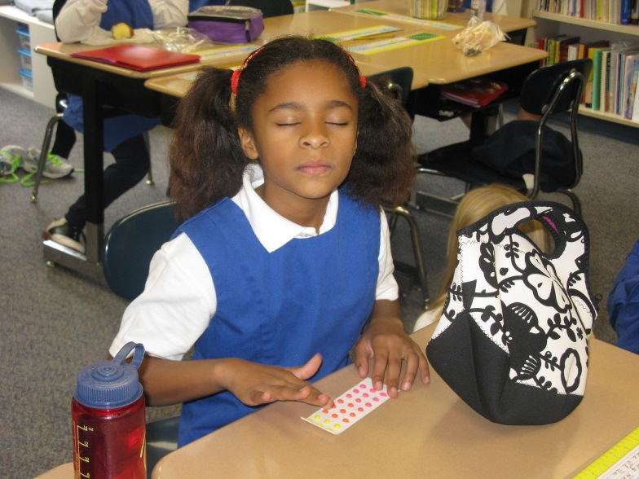

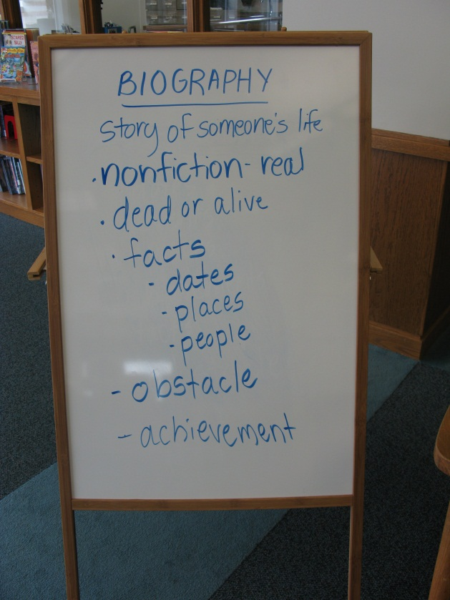

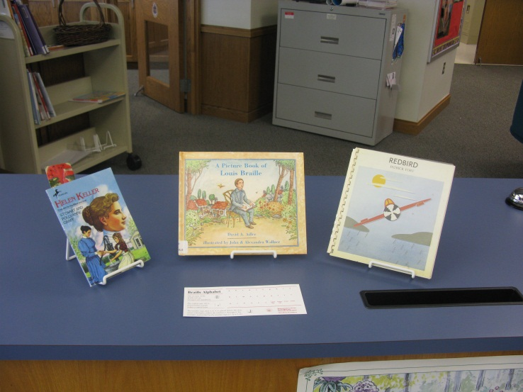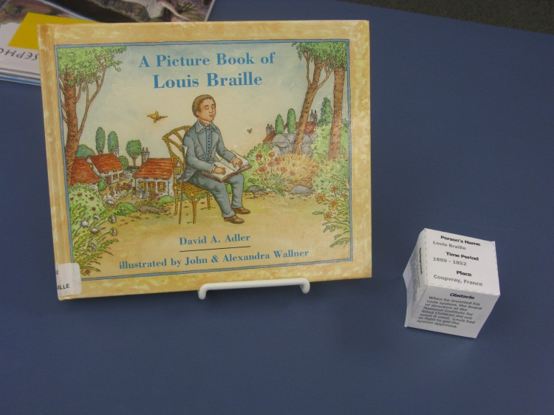

EXIT SLIP
Today I learned about:

I feel ________ about what I learned in today’s class (circle one):

Here’s what I know about biographies:

Here’s what I know about Louis Braille:

Some questions I have are:

